VIETNAM NATIONAL UNIVERSITY – HO CHI MINH CITY THE INTERNATIONAL UNIVERSITY OF COMPUTER SCIENCE AND ENGINEERING


Building a chatbot using LangChain for querying information in
Vietnamese legal documents
Student Name: Phạm Huỳnh Thanh Quân
Student ID: ITDSIU21110
Supervisor: Dr. Nguyen Thi Thanh Sang

A thesis submitted to the School of Computer Science of Engineering in partial fulfillment of the requirements for the degree of Bachelor of Data Science

Ho Chi Minh City, Viet Nam

THESIS TITLE

APPROVED BY:

,

,

,

,

THESIS COMMITTEE
Acknowledgments
First, sincere thanks are extended to Dr. Nguyen Thi Thanh Sang, the thesis supervisor. Her devoted academic guidance, continuous support, and encouragement were invaluable throughout the completion of this thesis. Her mentorship went beyond academic knowledge by providing valuable insights from academic and professional experience, as well as meaningful guidance for future development.
Second, appreciation is expressed to the School of Computer Science and Engineering, International University, Vietnam National University, Ho Chi Minh City. This institution has provided an academic environment that supported the development of knowledge and confidence in the field of Data Science. The academic environment and the high scientific standards of the faculty have greatly contributed to this development.
Third, sincere gratitude is extended to the author’s parents and family for their unconditional support, encouragement, and sacrifices throughout the academic journey and the completion of this thesis.

Table of Contents

Chapter 1: Introduction 11
1.1 Background and Motivation 11
1.2 Problem Statement 12
1.3 Objective of the Study 12
1.4 Research questions 13
1.5 Scope and Limitations 14
1.6 Structure of the Thesis 14
Chapter 2: Literature Review 15
2.1 Overview of Legal Documents and Their Challenges 15
2.2 Retrieval-Augmented Generation (RAG) 16
2.3 Embedding Models 17
2.4 Vector Databases for Retrieval 18
2.5 Large Language Models (LLMs) 18
Chapter 3: Methodology 19
3.1 Research Design Overview 19
3.2. System Architecture 20
3.3. Dataset Description 21
3.3.1. Legal Content Corpus 21
3.3.2. Question–Answer Corpus 22
3.4 Data Preprocessing 23
3.4.1. Text Cleaning 23
3.4.2. Parsing the Legal Content File 24
3.4.3. Parsing the QA File 25
3.5. Document Construction and Metadata Design 27
3.5.1. Content Documents 27
3.5.2. QA Documents 28
3.5.3. Metadata Utility 28
3.6 Embedding and Vector Database Construction 29
3.6.1 Embedding Model 29
3.6.2. Vector Storage 30
3.6.3. Rate Limiting and Safe Indexing 30
3.7. Retrieval Strategies 31
3.7.1. Similarity Retrieval 31
3.7.2. Maximal Marginal Relevance Retrieval 31
3.7.3. Source Comparison 32
3.8. Large Language Model and Prompting Design 34
3.8.1. Gemini as the Answer Generator 34
3.8.2. Prompt Template 35
3.8.3. Generation Fallback 36
3.9. Evaluation Design 36
3.9.1. Evaluation Scenarios 36
3.9.2. Generation of Similar Questions 37
3.9.3. Out-of-Set Related Questions 37
3.10. Evaluation Metrics 37
3.10.1. Exact Match 37
3.10.2. Soft Contains 37
3.10.3. Token-level F1 37
3.10.4. BERTScore 37
3.10.5. Retrieval Hit 38
3.10.6. Acceptable Match 38
3.10.7. Time-based Metrics 38
3.11. User Interface and Demonstration 38
Chapter 4: EXPERIMENTS AND RESULTS 39
4.1 Experiments 39
4.1.1. Experimental Setup 40
4.1.2. Compared Modes 41
4.1.3. Evaluation Metrics 41
4.2. Results 42
4.2.1. Results on Exact Questions from the QA Set 42
4.2.2. Results on Similar Questions 44
4.2.3. Results on Out-of-Set but Related Questions 46
4.3. Discussion 48
4.3.1. Which Mode Was Faster? 48
4.3.2. Which Mode Was More Accurate? 48
4.3.3. When Was the QA Source Better? 49
4.3.4. When Was the Content Source Better? 50
4.3.5. Interpretation of Exact Match Results 50
4.3.6. Limitations of the Current Experiment 51
CHAPTER 5: DISCUSSION AND EVALUATION 52
5.1 Overall Discussion 52
5.1.1 Comparison Between Content Source and QA Source 52
5.1.2 Accuracy Analysis 52
5.1.3 Latency Analysis 53
5.2 Evaluation by Question Type 53
5.2.1 Exact Questions from the QA Set 53
5.2.2 Similar Questions 54
5.2.3 Out-of-Set but Related Questions 54
5.3 System Limitations 54
5.4 Practical Implications 55
CHAPTER 6: CONCLUSION AND FUTURE WORK 55
6.1. Conclusion 55
6.2. Future Work 57
REFERENCES 58
APPENDICES 59
Appendix A 59
Dataset Samples 59
Appendix B 60
Prompt and Metadata Design 60
Appendix C 60
Experimental Settings and Additional Results 61
Appendix D 61
Interface and Workflow Figures 61

List of abbreviations
Embedding | Vector representation of text
Retriever | Component used to retrieve relevant documents
Prompt | Input instruction given to an LLM
Context | Retrieved information used to generate answers
Gemini | Google’s Large Language Model
MMR | Maximal Marginal Relevance
SIM | Similarity Search
EM | Exact Match
F1 | F1 Score (evaluation metric)

Abstract
However, due to the fast-paced development of LLMs, question-answering models have seen a considerable improvement. However, the application of such models to domain documents is limited since responses may be incorrect if the model is not grounded in relevant data. This problem is even more critical in the field of law since correctness, consistency, and provenance are extremely important. The current thesis discusses RAG architecture that can be applied to developing a chatbot to answer questions from Vietnamese legal documents.
The proposed system consists of several main components: text preprocessing, document construction, semantic embedding, vector database indexing, retrieval, and answer generation. Legal documents are converted into structured text segments, embedded into vector representations, and stored in a Chroma vector database. Two retrieval strategies, namely similarity search (SIM) and maximal marginal relevance (MMR), are evaluated to determine their suitability for Vietnamese legal question answering. The retrieved context is then provided to Gemini as the answer-generation model.

As seen from the experiments, the incorporation of the retrieval mechanism leads to improved reliability of the chatbot through ensuring that its generated answers are based on relevant legal information. From the analysis of the different configurations of the system, it is apparent that there is a trade-off where more powerful generative models provide accurate answers while those optimized for speed have low latency.

Overall, it can be seen that the combination of semantic retrieval and large language model allows improving the reliability and accuracy of a chatbot that answers questions related to Vietnamese law. Although the system developed currently is limited by the number of documents available, the suggested approach provides a good basis for developing legal information systems in the future.

Chapter 1: Introduction

Background and Motivation
The recent breakthroughs in Artificial Intelligence (AI) technology with an emphasis on Natural Language Processing (NLP) make it possible to design more sophisticated language-oriented software. The large language models (LLM) like Gemini have been successfully implemented for various tasks, including summarization, question answering, and conversations with a user. Thus, there is a possibility to design more intelligent software systems that will help people extract useful information from difficult texts.
Despite all their merits, the large language models still experience some problems while being implemented for some specific purposes. One of the domains that represent considerable challenges for the implementation of LLM is legal document processing. The main problem related to the application of NLP techniques to this sphere lies in the specificity of legal texts that are usually very long, structured, and contain a formal language. As a result, it is likely that a general purpose language model could provide a poor quality response to legal questions because they can produce incomplete, vague, or even false results due to a phenomenon known as hallucinations.
This paper presents Retrieval-Augmented Generation (RAG) as a technique to counter the deficiencies of stand-alone language models. While some models can produce responses by themselves without relying on any external resources, RAG makes use of the retrieved relevant documents before generating an answer based on the retrieved information. This technique is applicable in many areas like law, where answers need to be based on documents.
The situation of intelligent legal information retrieval systems in Vietnam is poor. There are plenty of systems that only rely on keyword-based retrieval that does not consider semantics of users’ questions in natural language. It results in the appearance of a semantic gap between legal documents and laymen users that are unable to formulate search requests using the exact terms needed for retrieval. Thus, the necessity of a Vietnamese legal chatbot arises.
For this reason, in this paper, we create a chatbot for retrieving Vietnamese legal documents with the use of RAG. Our model uses LangChain, vector-based retrieval, Chroma, and Gemini. Besides, we examine different retrieval sources and methods suitable for Vietnamese legal question answering.

Problem Statement
Despite the impressive ability of LLMs to perform well in many NLP problems, some issues can arise when applying such models to Vietnamese legal question answering. First, an individual model alone will not ensure the accuracy of the answers to legal queries since there is no legal text at the disposal of the model, and hence the answer might be based on learned patterns or assumptions instead of the existing regulations. Second, conventional keyword search approaches often fail to work for natural language legal questions. In this case, the legal text will have specific terminology while the users can ask the same question in plain language. Third, legal texts tend to be long, hierarchical, and context-driven. Therefore, solving legal questions may require finding the relevant article, procedure, organization, or time condition, and so legal texts need to be processed taking into account context and producing short answers.
Fourth, many existing systems separate the processes of retrieval and generation. Retrieval-oriented systems can provide answers without providing a solution to the question, and this forces the user to analyze the legal text by himself/herself. Generation-oriented systems can provide natural language answers, but without any valid justification. Therefore, an ideal legal question-answering system must combine both retrieval and generation. Thus, there is a need for a system that can do the following tasks:
• understand the queries provided in Vietnamese;
• perform semantic search instead of lexical search for legal data;
• generate natural language answers based on the legal data found.

Objective of the Study
The main goal of the present thesis is to design a Vietnamese legal chatbot based on the RAG paradigm. The system should help make legal information accessible through semantic search and generation of answers by using the LLM.
To achieve the mentioned goal, the following goals are set for the research:
- To design and implement the RAG-based architecture of Vietnamese legal queries answering system, which involves prepossessing, document construction, metadata annotation, vectorization, indexing, retrieval, and answer generation.
- To develop and compare two retrieval sources based on the same legal document collection: legal corpus and Q&A corpus.
- To explore the techniques of semantic search of Vietnamese legal documents by means of embeddings and vector database technologies.
- To compare various retrieval systems with focus on similarity-based search and maximal marginal relevance technique.
- To integrate the large language model based on Gemini into the generation component to create relevant legal answers.
- To test the proposed chatbot on various types of queries: exact, semantically similar, out-of-vocabulary related.
- To analyze the effectiveness and quality of the system via lexical and semantic metrics and latency metrics.
- To develop the user interface for chatbot interaction based on Gradio platform.

Research questions
In this thesis, the following research questions will be explored:
1. How can an RAG architecture be designed and applied to Vietnamese Legal Question Answering tasks?
2. How do two different retrieval resources – the legal documents corpus and the questions and answers corpus – affect the quality of context retrieval and the generated response?
3. How do different retrieval methods, like Similarity Search, Maximal Marginal Relevance, affect the chatbot's ability to respond?
4. How does the developed RAG system address the problem of hallucinations compared to a simple LLM system?
5. What is the performance of the developed system for different types of questions, like exact questions, similar questions, and related questions but not in the training set?
6. What is the best setting of the system in terms of quality/latency trade-off?

Scope and Limitations
In this thesis, the focus is on designing and evaluating the performance of an intelligent chatbot system for Vietnamese legal text retrieval based on the Retrieval-Augmented Generation (RAG) architecture. This paper describes the key stages of building a question-answering pipeline, which includes text preprocessing, text parsing, metadata creation, semantic embeddings, vector indexing, retrieval, and LLM response generation.
The domain of application is confined to legal texts represented in the form of structured textual data. Specifically, experiments rely on Vietnamese legal documents related to community mediation, where the key source document is Resolution 01/2014/NQLT/CP-UBTƯMTTQVN. The solution involves using LangChain, Chroma, Gemini embeddings, and Gemini language models. The focus of evaluation is placed on the comparison of two retrieval sources and different retrieval strategies.
While the results of the proposed system seem promising, there are several limitations that should be pointed out. First, the current research is based on the small dataset comprising the texts extracted from a single legal source and created manually question-answer pairs. Consequently, the research should be regarded as a case study rather than a legal QA benchmark. Second, the efficiency of the designed system depends heavily on the quality of text preprocessing, segmentation, embeddings, and retrieval techniques; improper tuning of the processes will result in incomplete context extraction and, thus, poor answers. Third, while retrieval helps to reduce hallucinations, the output still relies on the LLM reasoning and generation abilities and, hence, incorrect answers may be produced. Fourth, the current solution does not involve any advanced approaches such as hybrid retrieval, reranking, multiple query expansion, or legal citation validation; however, even though they help to increase the output accuracy, their application is out of the scope of this thesis. Fifth, the evaluations were done in the controlled environment and involved only limited API access, therefore, the approach needs further validation on a large datasets.

Structure of the Thesis
Outline of Thesis:
Chapter 1: Introduction
The introduction gives the background and rationale for the study, along with research question, objectives, problem statement, scope, and limitation of the study.

Chapter 2: Literature Review
This chapter provides an overview of the relevant literature on legal document retrieval, Retrieval-Augmented Generation (RAG), embedding models, vector databases, and large language models, focusing on their uses in answering Vietnamese legal questions.

Chapter 3: Methodology
In this chapter, the system design, dataset used, document creation, meta-data creation, embedding and vector indexing methods, query retrieval, prompting method, and evaluation process are explained.
Chapter 4: Experiments and Results
Here, we describe the experiments performed and discuss the results from comparison of different retrieval sources for different types of questions.
Chapter 5: Discussion and Evaluation
The discussion chapter further elaborates on the results, highlighting the merits and demerits of different retrieval sources. Here, we discuss the effectiveness of the system in various scenarios and enumerate the weaknesses of the present system.
Chapter 6: Conclusion and Future Work
This chapter concludes the dissertation by describing its contributions and highlighting its main findings and suggesting possible future directions.

Chapter 2: Literature Review

2.1 Overview of Legal Documents and Their Challenges
Legislative texts represent an essential tool to regulate various social, economical and administrative activities. As it happens in Vietnam and in any country, there is a great deal of legislative texts such as laws, decrees, circulars, resolutions between ministers. One of the specific features of those documents is the formality, extensiveness and complexity of them. Even though those aspects help to be precise about legal texts, it becomes hard for an ordinary person to obtain needed information.
Modern information retrieval systems for legal content operate with keyword matching. Despite the fact that those systems may work perfectly fine in case a user knows specialized terminology precisely, they fail in case there is a natural language request or there is a paraphrasing that represents the same meaning. It becomes harder because of hierarchical organization of legal language and thus, it is likely to get irrelevant results.
Another problem is that some of the legal documents require context awareness but not sentence level matching. Inquiries of a legal nature may depend on procedure steps, duties, deadlines or inter-Clause interaction. It means that a system that should answer legal queries has to do something else except to extract relevant text fragments from a document.
To cope with these problems, there is a need for retrieval-augmented systems – a type of those that use external knowledge to help with data retrieval before generation. It is especially important for the domain of law, as well as for Vietnamese legal domain, because precision and traceability are very important there.

2.2 Retrieval-Augmented Generation (RAG)
Retrieval-Augmented Generation (RAG) is now increasingly used as a means to augment the accuracy and reliability of the large language model system. Instead of using only the knowledge of the model, RAG uses an extra retrieval step to provide evidence before responding with any answer. This method, first proposed by Lewis et al., proved its efficacy in handling knowledge-intensive natural language processing problems.
RAG is becoming popular as a way to increase precision and reliability of the large language models. While previous approaches were completely dependent on the knowledge inside the language model, adding a step of retrieval provides that evidence before responding to the question. This method was proposed by Lewis et al. and proved to be effective in case of NLP tasks involving knowledge.
RAG is now being considered as a method that would help to increase the accuracy and efficiency of the large language models. The difference with previous methods consisted in not being dependent on the knowledge inside the language model but rather retrieving the evidence before giving an answer.
The efficiency of the retrieval-augmented generation system depends mostly on the efficiency of the retrieval itself. As the retriever does not retrieve enough information, the generator will not be able to give correct answers. Therefore, it becomes important how the retrieval works, what kind of chunking is used, the quality of the embeddings, and prompts are designed. Furthermore, using different methods of retrieval, such as MMR, can help generate more diverse retrieval context without much overlap between passages.
This is why the RAG methodology is applicable for this thesis where answering legal questions and comparing retrieval sources are among the objectives.

2.3 Embedding Models
The embedding model is an indispensable element of any modern semantic search engine. The purpose of embedding models is to represent textual information in dense vector spaces that will retain semantic relations between entities. Unlike sparse representation like bag-of-words or TF-IDF, embedding models pay particular attention to contextually similar sentences.
The early retrieval models used approaches based on the statistics of lexical elements that worked fine for keyword-based searches but lacked the ability to understand semantic relationships. With the advent of transformers' architectures like BERT, it became possible to develop contextually aware representations that considerably improved NLP tasks and thus led to the creation of embeddings of sentences and even whole documents.
The choice of embeddings plays a key role in retrieval-augmented generation as they define how efficiently relevant data could be found given the provided query. When the vector space encoding semantics is created properly, then two queries having different lexicon but the same semantics can retrieve the right supporting documents.
In the current thesis, the Gemini embeddings were used to represent both the corpus of legal documents and the corpus of questions-answers. According to the documentation of the Gemini API, the gemini-embedding-001 model can be used to perform tasks in text-only scenario including semantic searches and document retrieval. Newer Gemini embedding models allow retrieving multimodal data, but gemini-embedding-001 will be enough for text-only retrieval.
The quality of embeddings plays a major role as badly encoded semantics may result in irrelevant passage being found, thus affecting the quality of the output. Therefore, the selection of embeddings should be considered carefully.

2.4 Vector Databases for Retrieval
Vector databases make an important part of the RAG architecture because of the ability of storing and searching high-dimensional vector representations. Vector databases can be distinguished from relational and keyword-based databases since they are designed specifically for similarity-based retrieval. The architecture of vector databases makes it possible to implement semantic retrieval that can be described as retrieval of information related semantically and not necessarily matching keywords.
There is a set of vector search engines designed specifically for large-scale embedding tasks. One of the popular tools is FAISS that is known for its fast similarity search for dense vectors. Lightweight vector databases have gained popularity recently in NLP applications.
In the framework of this thesis, Chroma vector database was used. Concerning its features, Chroma is well-suited for retrieval-based NLP tasks, including easy database creation and management, and similarity search. Moreover, Chroma is perfectly compatible with LangChain applications and can be used for quick prototyping and building chatbots. Both LangChain documentation and Chroma documentation confirm support of Chroma vector databases in LangChain applications.
Chroma makes it possible to compare two retrieval sources – structured corpus of legal texts and Q&A corpus. Each corpus is indexed separately for comparing their retrieval performance based on the same generative model.

2.5 Large Language Models (LLMs)
The vector database is an essential element of the Retrieval-Augmented Generation (RAG) architecture owing to its ability to store and retrieve high-dimensional vector representations. In contrast to relational and keyword databases, the vector databases are specifically designed for similarity-based retrieval. Architectural properties of the vector database provide semantic retrieval which is a type of retrieval that involves retrieving of information semantically related rather than just being keyword-related.

There exists a range of vector search engines created to perform large-scale embedding. FAISS is the widely known one as it provides fast similarity search on dense vectors. Light-weight vector databases became popular in the scope of NLP.

In the current thesis, the Chroma vector database has been used. Speaking about the characteristics of Chroma, it is worth noting that it is perfect for retrieval-based NLP and easy to create/manage and to perform similarity searches. Moreover, Chroma is fully compatible with LangChain applications and suitable for prototyping and chatbot creation. Both LangChain and Chroma documentation prove support of Chroma vector databases by LangChain applications.

Chroma allows comparing two sources of retrieval – a structured corpus of legal texts and Q&A corpus. Each of these corpora will be separately indexed to perform comparison of the retrieval in the context of a common generative model.

Chapter 3: Methodology

3.1 Research Design Overview
This study develops a retrieval-augmented legal chatbot for Vietnamese legal documents using LangChain and Gemini. The methodology compares the performance of two retrieval sources under the same LLM-based generation setting.
The first retrieval source is a document corpus created based on the legal database structured as Item – Title – Content. In this case, every single item in the corpus contains either a full legal text or a part of it extracted from Resolution 01/2014/NQLT/CP-UBTƯMTTQVN. This corpus was compiled from the Vietnamese Legal Database found on Kaggle and archive (1)\data\legal_truncated_corpus.csv
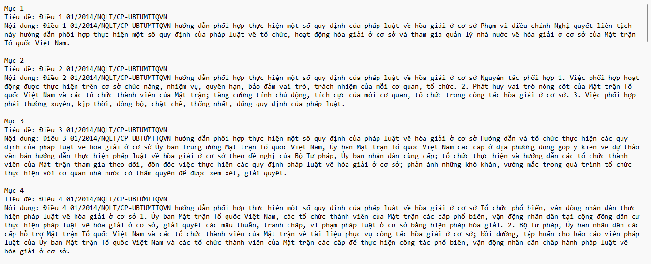
Second, there is a QA corpus which consists of manually created QA pairs based on the same legal document. This is used as another retrieval source as well as the benchmark dataset to evaluate the system’s performance.
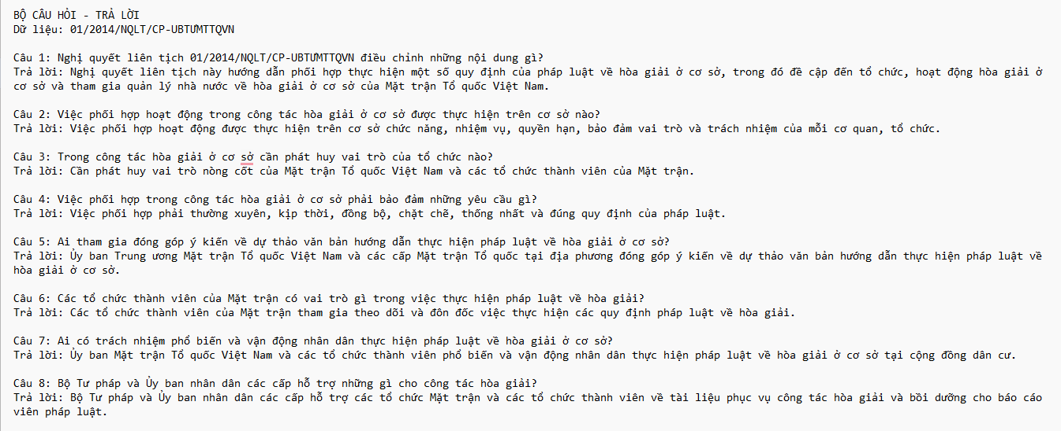
This study uses a RAG approach. First of all, the input texts undergo parsing and transformation into structured documents. Then, these documents get embedded into the vector space and stored in a vector database. As for user queries, the closest in terms of semantics documents are retrieved, and the retrieved context is provided to Gemini to generate answers. Finally, the answers are evaluated according to lexical, semantic, and latency measures.

The research approach does not cover only exact FAQs-like questions. The ability of the chatbot to answer semantically similar questions and legal questions outside the question-answer set is also evaluated. This point is critical because users often ask questions in different words than those used in the QA dataset.

3.2. System Architecture
The proposed system consists of five major components:
- Data ingestion and preprocessing
- Document construction with metadata
- Embedding and vector indexing
- Semantic retrieval and answer generation
- Evaluation and interface presentation
The overall workflow is as follows:

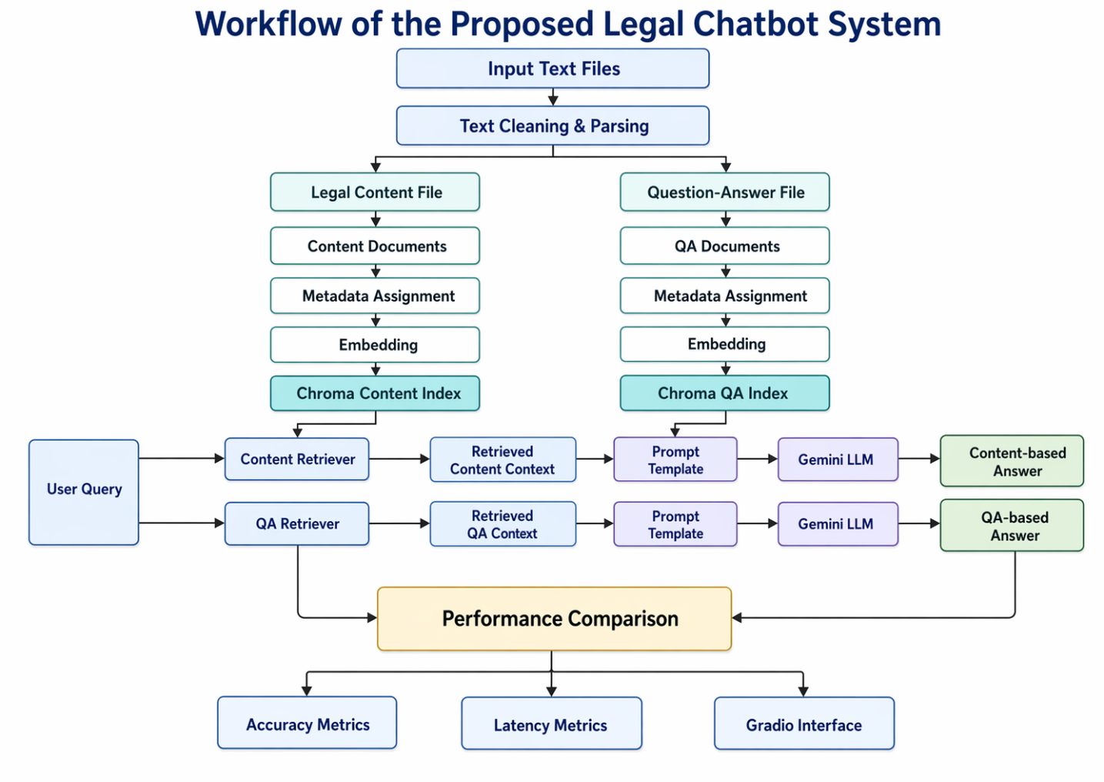

3.3. Dataset Description

3.3.1. Legal Content Corpus
In this dataset, the first one consists of a file that contains legal texts split into different segments that have a format of Mục - Tiêu đề - Nội dung. Every segment stands for an individual unit of legal information from the Resolution 01/2014/NQLT/CP-UBTƯMTTQVN. The title is usually the article number of the legal text whereas the content part stands for the corresponding explanation. The corpus serves as a database of content retrieval aiming at imitating an information search process within legal documents.
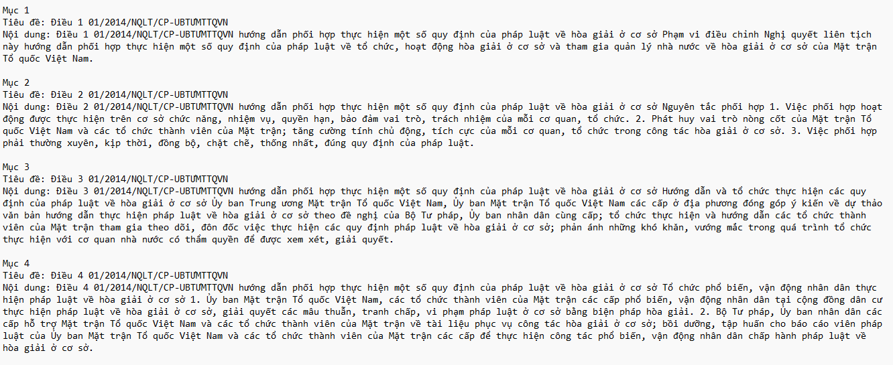

3.3.2. Question–Answer Corpus
Second, the database consists of a question-answer sheet containing 30 question-answer pairs based on the same legal text. This sheet includes one question and one correct answer for each pair. The questions are based on issues like regulation, coordination, supervision, inspection, review and summarization, election of conciliators, and the legal effect of the law.
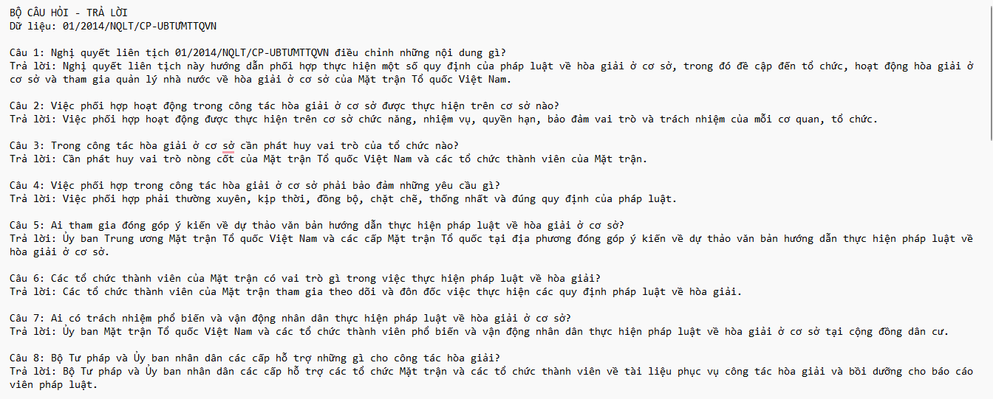
The corpus has two purposes:

- It acts as a QA retrieval resource in which the system retrieves answers directly from the question-answer pair;
- It acts as a gold standard dataset in which the chatbot answer will be compared with the reference answer.

3.4 Data Preprocessing

3.4.1. Text Cleaning
Both the input text files go through a process of normalization through cleaning. The process deals with problems of format, such as white spaces, invisible unicode, and incorrect line breaks. Normalization aims at improving parsing accuracy and ensuring consistency in document building.

Cleaning process involves:
- Removal of non-breaking and other invisible characters,
- Consistent line breaks,
- Multiple spaces removal,
- Blank line removal.

Such a process is necessary due to the fact that plain text files have problems with their formats, which might affect the parsing accuracy and embedding.
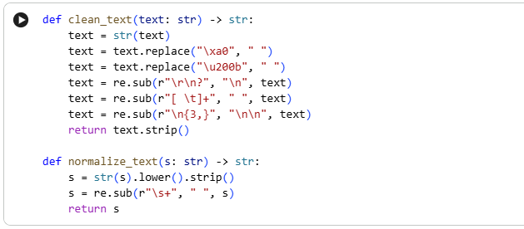

3.4.2. Parsing the Legal Content File
The parsing of the legal document content file occurs by identifying the following repeated structure:
- Mục
- Tiêu đề
- Nội dung

The identified blocks are then transformed to one record with the following elements:
- item_id
- title
- content
- article_number
- legal_code

Here, the article_number will be extracted based on the rules set up for text matching within the title, whereas the legal_code will be extracted using the rules provided for legal citation extraction from the text. The above parsing scheme makes each legal provision an independent document.
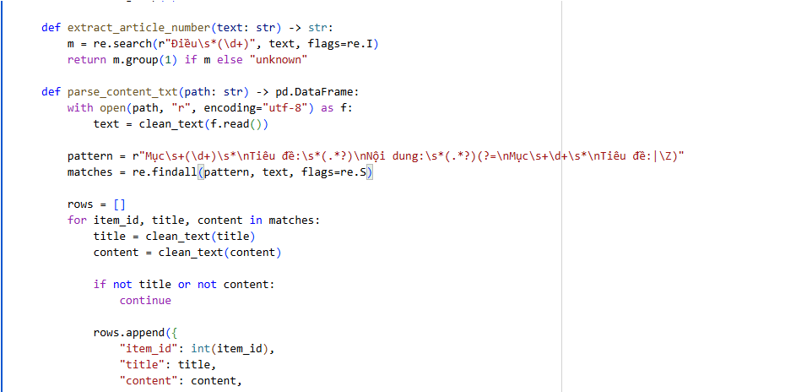
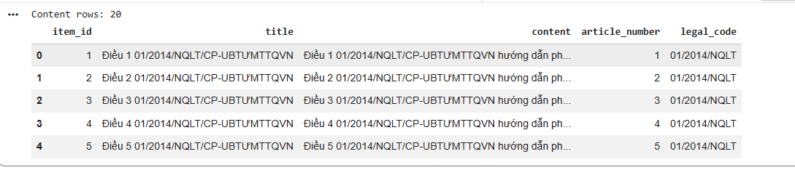

3.4.3. Parsing the QA File
The QA data is analyzed on the basis of recurring pattern below:
- Câu x:
- Trả lời:

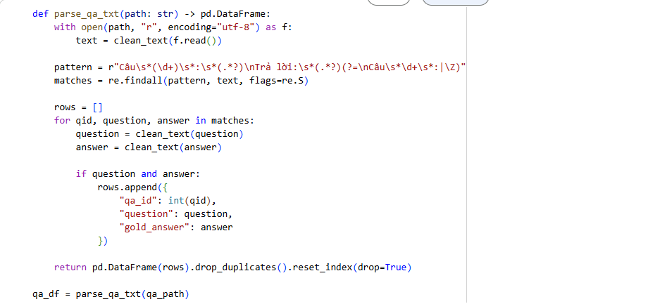

Each entry will be represented in one formatted line that includes:
- qa_id
- question
- gold_answer
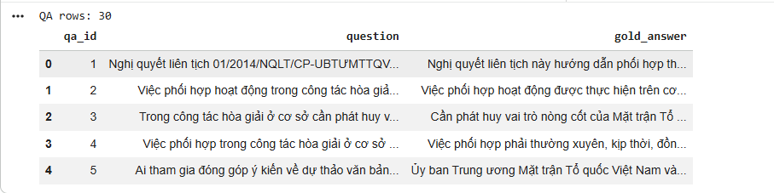

It will facilitate both retrieving and evaluating. The parsed question can further be used to generate the paraphrase questions for evaluation purposes.

3.5. Document Construction and Metadata Design
After preprocessing, the datasets are converted into LangChain Document objects.

3.5.1. Content Documents
For the content source, each document stores:
- page_content = "Tiêu đề: ... \n Nội dung: ..."
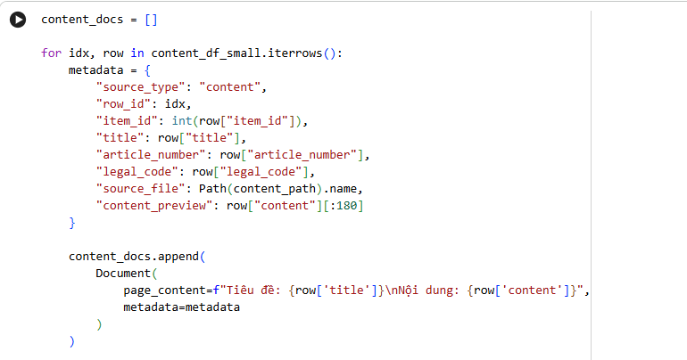
and metadata fields including:
- source_type
- row_id
- item_id
- Title
- article_number
- legal_code
- source_file
- content_preview

3.5.2. QA Documents
For the QA source, each document stores:
- page_content = "Câu hỏi: ... \n Trả lời: ..."
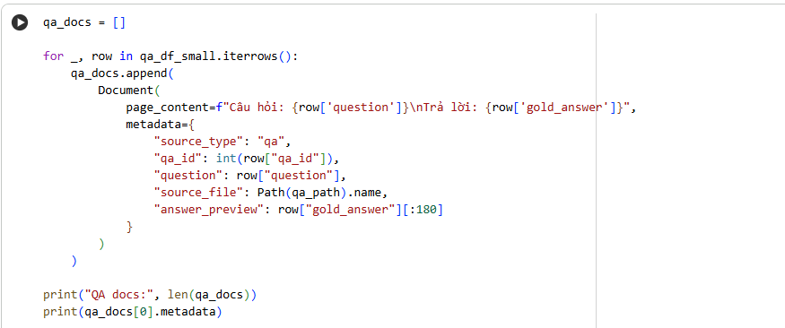
and metadata fields including:
- source_type
- qa_id
- question
- source_file
- answer_preview

3.5.3. Metadata Utility
Metadata has a critical role in the system. It can be used for:

- identifying the relevant legal item or QA pair that is selected,
- providing evidence of retrieval in the interface,
- analyzing the retrieval pattern of various modes,
- comparing content-based and QA-based retrieval.

In this way, metadata enhances the interpretation and evaluation processes of the system.

3.6 Embedding and Vector Database Construction

3.6.1 Embedding Model
The experiment involves the use of Gemini text embeddings for transforming the legal texts and question-answer pairs into vectors. This step is crucial for enabling the chatbot to conduct semantic searches beyond exact lexical matches to similar or synonymous queries.

Embedding is performed on both the content and QA corpora in order to provide a comparable analysis between the two retrieval sources.
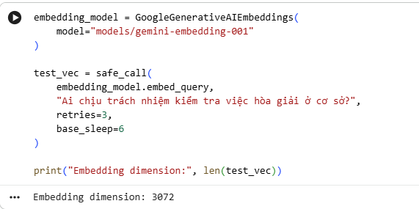

3.6.2. Vector Storage
The documents are stored in the vector database Chroma. There are two distinct in-memory Chroma collections:
- one to hold the content corpus
- one to hold the QA corpus

This distinction is made since the analysis focuses on the retrieval performance of both corpora separately.
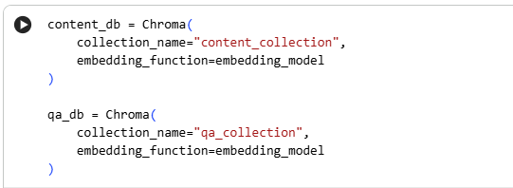

3.6.3. Rate Limiting and Safe Indexing
Since the system runs under the free API quota, the following safeguards are included in the embedding pipeline:
- small batches of documents
- waiting periods between embedding requests
- retry logic
- exponential backoff for transient quota errors

These will ensure that the process of indexing is not halted due to resource issues.
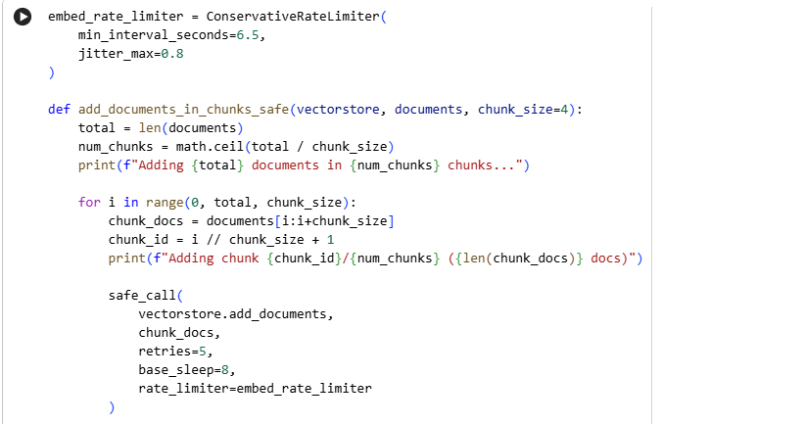

3.7. Retrieval Strategies
There are two retrieval techniques employed in the experiments conducted:

3.7.1. Similarity Retrieval
The first method that is utilized is the similarity-based retrieval. In practice, the process involves retrieval of documents whose vector is similar to the vector of the query input embedding. It is simple and easy in nature, particularly where the meaning of the user query is related to the indexed documents.

3.7.2. Maximal Marginal Relevance Retrieval
The second technique is called Maximal Marginal Relevance (MMR). Unlike the classical similarity retrieval techniques which focus on one element, MMR tries to achieve equilibrium between (i) relevance to the query and (ii) diversity of the retrieved elements. This technique proves especially useful in cases where there are too many similar top-ranked elements or when several parts of the law are relevant.

3.7.3. Source Comparison
Each retrieval method is independently used on:
- Content repository
- QA repository

This leads to several modes that can be compared, like:
- CONTENT_SIM + FLASH
- CONTENT_MMR + FLASH
- QA_SIM + FLASH
- QA_MMR + FLASH

Elaboration on Four Modes:
1. CONTENT_SIM + FLASH
CONTENT suggests that the system will extract information from the legal content corpus. The legal content corpus includes three parts such as item, title, and content structure. SIM implies that the similarity search is involved in which documents that have the closest embedding to the user’s query will be selected. FLASH means that the output will be generated through Gemini Flash.
Implication:
This mode should be used if the user asks open-ended questions or queries that are not included in the QA dataset as the data source is the original legal provisions.

2. CONTENT_MMR + FLASH
CONTENT means that the search will take place within the corpus of the legally valid documents. MMR means Maximal Marginal Relevance which implies that the retrieved documents should be not only relevant to the query but also diverse. FLASH means that the output will be generated using Gemini Flash.
Explanation:
This technique can be applied when the task is to retrieve relevant and non-redundant context to avoid returning similar legal texts.

3. QA_SIM + FLASH
QA means "Question – Answer" corpus in which information is extracted from handcrafted QA pairs. SIM means "Similarity Search" which means that the most semantically similar QA pair to the query is searched. FLASH means "Gemini Flash" through which the answer to the question is generated.
Explanation:
Good results can be expected in case the user's question corresponds to the handcrafted QA database as the knowledge base includes question-answer pairs.

4. QA_MMR + FLASH
QA implies that the search will take place in order to extract Q&A from the corpus of questions and answers. MMR means Maximal Marginal Relevance which is used to extract QA pairs that are relevant and non-redundant. FLASH implies generating the answer via Gemini Flash.
Interpretation:
In this case, the user's query can relate to several similar QA pairs and therefore, several QA pairs should be extracted.
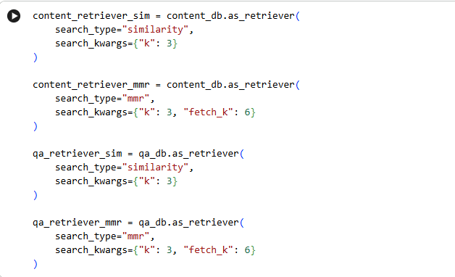

The application of parallel retrieval pipelines enables the research to explore whether the quality of answers depends more on retrieval method or source.

3.8. Large Language Model and Prompting Design

3.8.1. Gemini as the Answer Generator
Once the necessary documents have been identified, the system employs a Gemini LLM to provide the final answer. However, the LLM does not provide an answer using its parametric memory. It can only answer based on the information retrieved from the documents.
The above design adheres to the principle of retrieval-augmented generation, where the external documents are used as the basis for generation.
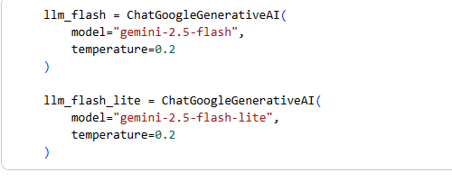

3.8.2. Prompt Template
The prompt template is constrained in an attempt to prevent hallucinations. The instruction explicitly tells the model to:
- answer based on the context provided alone,
- not include any external information,
- output a default answer when the context is inadequate.

Such a prompt design is essential in the field of law, as unreliable statements can lower credibility.
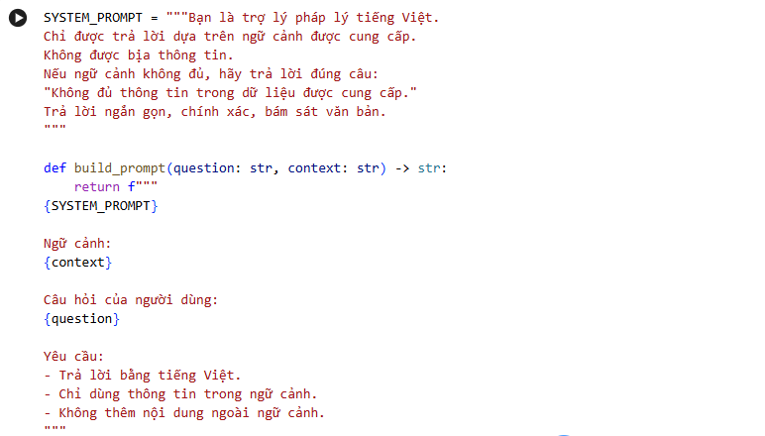

3.8.3. Generation Fallback
In case of failure in generating LLM for any reasons such as API problems or other constraints while running, another approach could be considered which involves retrieving the answer from the context retrieved by the system.

3.9. Evaluation Design

3.9.1. Evaluation Scenarios
In order to evaluate the different difficulty levels for matching queries, the experimental design is divided into three categories:
- Exact queries from QA set
- Exact queries which correspond to the questions prepared.
- Paraphrases of questions
- These are paraphrases of the questions prepared as part of the QA set.
- External queries, but related to law
- External queries that have no relation to the questions in the QA set but relate to the field of law in some way.

This categorization allows evaluation of the ability of the system to match both exact questions and paraphrases as well as legal queries.

3.9.2. Generation of Similar Questions
Methodology of semantic retrieval evaluation consists in the generation of several paraphrases for every given question-answer (QA) pair, using paraphrasing rules. Such methodology tries to imitate users' behavior better than using exact questions only.

3.9.3. Out-of-Set Related Questions
Where the example is not present in the QA corpus, a different set of hand-crafted examples will be used instead. The hand-crafted prompts could have information about processes, timelines, conditions, or any other extraordinary situations. This is important because this will test the generalization abilities of the model outside of the training data.

3.10. Evaluation Metrics
The paper employs several evaluation methods to measure both accuracy and efficiency of the system.

3.10.1. Exact Match
Exact Match tests if the answer produced by the model matches the answer provided in the gold data after normalization. While this test may help in some cases, it is quite strict because it requires the answer to be an exact match in generative mode.

3.10.2. Soft Contains
Soft Contains tests if the answer generated by the model includes the answer provided in the gold data or vice versa.

3.10.3. Token-level F1
Token-level F1 score evaluates the similarity of words between the generated response and the reference response. It is a balance between precision and recall at the token level.

3.10.4. BERTScore
BERT Score evaluates the semantic similarity as opposed to similarity in terms of wording. This measure is highly applicable for legal question answering, since answers may be similar semantically but have different wording.

3.10.5. Retrieval Hit
Retrieval Hit checks whether the context retrieved contains relevant information necessary to respond to the question.

3.10.6. Acceptable Match
Acceptable Match is defined since the output provided by the bot might still be useful even if it does not correspond with the gold response. The acceptable match is that which either corresponds with the gold response or is proximal enough to the gold response using permissive matching. This criterion is very crucial in this thesis because it measures utility better than Exact Match.

3.10.7. Time-based Metrics
The following time values must be measured to assess the efficiency of the systems:
- Retrieval time;
- Generation time;
- Response time;
The necessity for these measurements lies in the fact that in addition to comparing answers, the comparison of usability is needed.

3.11. User Interface and Demonstration
Gradio Interface has been implemented to showcase the performance of the chatbot. In the interface, the user can enter a legal question and receive:
- Generated response,
- Extracted context,
- Metadata of the documents extracted,
- Latency details.
Using the comparison interface, the user query can be sent to both sources and thus allow one to compare and identify the source that provides the most appropriate response to a particular question.

Chapter 4: EXPERIMENTS AND RESULTS

4.1 Experiments
This chapter outlines the experimental setup and findings regarding the creation of the Vietnamese legal chatbot that is proposed. One of the primary goals of the experiment was to test the performance of two retrieval resources within the framework of one large language model: the content-based legal resource and the question-answer resource. The experiments were intended to examine not only the quality of answers produced by the chatbot but also the time of generation of the responses.

The content resource was created following the structure of legal texts: Item, Title, Content; each item was either a whole or a part of a resolution 01/2014/NQLT/CP-UBTƯMTTQVN.
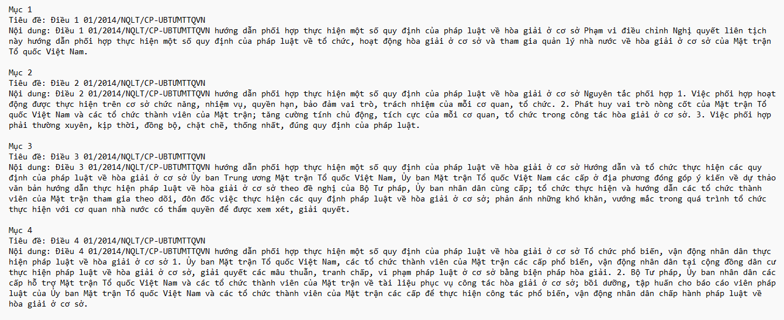

Second, a hand-crafted QA dataset was employed, which contained 30 question-answer pairs generated from the same legal document. The above dataset acted as both a retrieval dataset and a gold standard dataset.
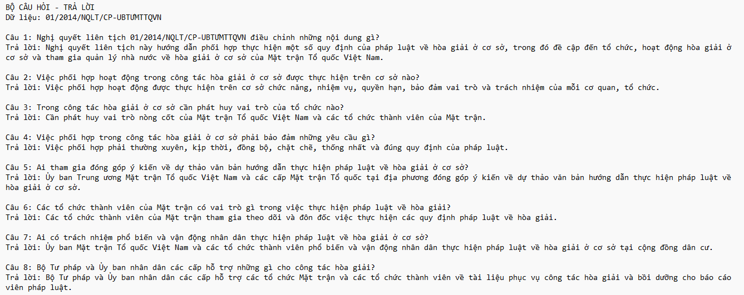
The experiments were performed using three different types of questions. Firstly, the algorithm was applied to the set of questions identical to those in the QA set. Second, the algorithm was checked for its efficiency when dealing with questions which were semantically close to the prepared questions and answers. Finally, the questions which belonged to the same legal field as those from the QA set were tested.

4.1.1. Experimental Setup
The chatbot system implementation was carried out using LangChain, Chroma as vector database, Gemini as the embedding model, and Gemini as the large language model. For each element from the content collection, a document object was generated with various metadata values, including Item ID, Title, Article Number, Legal Code, Source Type, and Content Preview. Likewise, for each question-answer pair, a document object was created with various metadata values, including Question ID, Original Question Text, and Answer Preview.

Two separate retrieval pipelines were designed:
- Content source pipeline, where retrieval was done on the legal content corpus.
- QA source pipeline, where retrieval was done on the QA corpus.

To provide a level playing field for comparison purposes, the two pipelines were implemented using the same embedding model and the same LLM model to generate answers. In addition, the retrieved context was fed into Gemini using a constrained prompt such that the model had to generate answers solely based on the context provided.
Due to the nature of performing these experiments on the basis of free API quotas, a prudent strategy of rate limiting and retries has been used. This included small batch sizes for embeddings, pauses between requests, and exponential backoffs.

4.1.2. Compared Modes
Currently at this stage, the comparison is being done between two exemplary approaches:
- CONTENT_SIM + FLASH
- QA_SIM + FLASH

Here, SIM stands for the similarity-based retrieval system. FLASH, on the other hand, refers to generating answers based on the Gemini Flash model.

4.1.3. Evaluation Metrics
Both correctness-based and timeliness-based metrics were used for evaluation.
Correctness-based metrics included:
- Exact Match (EM): Whether the predicted answer matches exactly the gold answer once normalized.
- Soft Contains: Whether the predicted answer contains the reference answer or vice versa.
- F1 on Token Level: The extent of token match between the predicted and gold answers.
- BERTScore: semantic similarity between the generated answer and the reference answer.
- Retrieval Hit: presence or absence of the correct or relevant supporting information in the context that was retrieved.
- Acceptable Match: a loose measure of whether the generated answer is correct or is a good match for the correct answer.

Time-based measures include:

- Retrieval Time
- Generation Time
- Response Time Total

Among these measures, the Acceptable Match measure is especially critical to this study because chatbot responses in legal contexts can still be valuable even when they do not exactly match the reference answer.

4.2. Results

4.2.1. Results on Exact Questions from the QA Set
The first experiment was aimed at evaluating the chatbot with respect to exact questions taken from the existing QA corpus. The idea of this benchmark was to assess system performance in an FAQ-type scenario where users ask questions formulated similarly to those used in the existing question-answer pairs. For the current pilot, there were three exact questions taken from the QA set. Both of these retrieval configurations were used for evaluation: QA_SIM + FLASH and CONTENT_SIM + FLASH.

According to the statistics provided in Table,the QA-based retrieval configuration outperformed CONTENT_SIM + FLASH in all evaluation metrics. First of all, QA_SIM + FLASH achieved 100% for such metrics as Acceptable Match, Exact Match, Token-level F1, and BERTScore F1. Thus, it means that the QA source was able to retrieve highly relevant question-answer pairs and helped the language model produce answers that corresponded lexically and semantically to the reference ones.

CONTENT_SIM + FLASH, on the contrary, achieved 66.67% in terms of Acceptable Match and 0% in terms of Exact Match. Although CONTENT_SIM + FLASH failed to reproduce reference answers exactly, this configuration managed to achieve the following scores: 76.48% for Token-level F1 and 87.12% for BERTScore F1. It means that CONTENT_SIM + FLASH is able to retrieve and produce partially relevant answers, which are, however, not as accurate as the answers produced by QA_SIM + FLASH.

Speaking about the response time, QA_SIM + FLASH appears to be more efficient since it requires 1.99 seconds to retrieve answers, whereas CONTENT_SIM + FLASH requires 6.30 seconds. This difference shows that the QA source not only helps to increase the precision of the answer but also decreases the time needed for its production. One reason for this might be that the retrieved context is shorter, more precise, and is already in Q&A format.

Thus, it is possible to conclude that the results of the experiment confirm the initial assumption that QA-based retrieval is better suited for exact questions extracted from the QA corpus. Indeed, as the questions posed by the user match the existing question-answer pairs, it is easier to find relevant answers and generate them in a more efficient way.
Experiment 1 :
Test | Mode | Acceptable Match (%) | Exact Match (%) | Token F1 (%) | BERTScore F1 (%) | Total Time (s)
Test 1 – Exact Questions | QA_SIM + FLASH | 100.00 | 100.00 | 100.00 | 100.00 | 1.985968
Test 1 – Exact Questions | CONTENT_SIM + FLASH | 66.67 | 0.00 | 76.48 | 87.12 | 6.299972

Overall, based on the results obtained, it is possible to conclude that the QA source is more efficient if the input question perfectly matches the QA corpus.

4.2.2. Results on Similar Questions
The second set of experiments involved the evaluation of the chatbot on semantically similar questions. For this benchmark, semantically similar questions were used, which consisted of paraphrases of the original QA dataset while retaining the same legal information needs but with different phrasing.

As can be seen from Table , the configuration QA_SIM + FLASH achieved the highest level of Acceptable Match – 100%. This means that the retrieval source based on QA was still capable of producing question-answer pairs that would be useful and relevant despite being reformulated in a different way. On the other hand, it got a 0% result in the Exact Match metric, which is explained by the fact that the generated answer was not identical to the one provided in references because of the generative nature of the system.

Speaking about the levels of lexical and semantic similarity, there were some similarities between the two configurations. Thus, QA_SIM + FLASH achieved a Token-level F1 score of 66.03% and BERTScore F1 of 80.97%, while CONTENT_SIM + FLASH achieved a slightly better Token-level F1 score of 68.65% and a slightly worse BERTScore F1 of 79.80%. Thus, we can conclude that the content-based source produced more lexically similar answers, while the QA source produced answers that were semantically similar to the reference ones.

When it comes to Acceptable Match scores, CONTENT_SIM + FLASH achieved a score of 66.67%, which is behind the one provided by the QA-based configuration. It means that while the content source could retrieve relevant provisions for several similar questions, it could not generate as many satisfactory answers. The difference lies in the fact that the content source makes the model infer an answer from the original text, while QA gives a more answer-oriented context.

When it comes to response time, CONTENT_SIM + FLASH was slightly faster, requiring approximately 90.72 seconds in comparison with 267.31 seconds needed by QA_SIM + FLASH. This result is opposite to the previous experiment and means that not only retrieval but also generation process affects the response time.

Overall, the results show that QA_SIM + FLASH configuration remained more consistent in terms of Acceptable Match for semantically similar questions. However, the content-based approach also showed good results in terms of lexical and semantic similarity and had a shorter response time.

Mode | Acceptable Match (%) | Exact Match (%) | Token F1 (%) | BERTScore F1 (%) | Total Time (s)
QA_SIM + FLASH | 100.00 | 0.00 | 66.03 | 80.97 | 267.311811
CONTENT_SIM + FLASH | 66.67 | 0.00 | 68.65 | 79.80 | 90.716429

4.2.3. Results on Out-of-Set but Related Questions
In the third experiment, we evaluated the chatbot on out-of-set but related questions. The questions that were used in this benchmark were not included in the prepared QA corpus, however, they were still semantically related to the same legal document. This benchmark was intended to test how well the system can deal with questions other than those which were covered by question-answer pairs and to estimate generalizability of each retrieval source.

As can be seen from Table , CONTENT_SIM + FLASH and QA_SIM + FLASH showed the same scores on Acceptable Match – 33.33% and Exact Match – 0%. Since there were only three out-of-set questions in the pilot, Acceptable Match at 33.33% means that only one answer out of three generated by the system was considered as acceptable. This result shows that the out-of-set questions were more difficult for both retrieval modes in comparison with exact and similar questions.

While the two modes had equal scores on Acceptable Match, their lexical and semantic performance differed. QA_SIM + FLASH showed better performance in terms of Token-level F1 – 39.43%, in contrast with 31.92% in case of CONTENT_SIM + FLASH, which means that QA-based mode had slightly more word-level similarity with the reference answers. At the same time, CONTENT_SIM + FLASH had better BERTScore F1 – 73.02%, in contrast with 70.47% for QA_SIM + FLASH, which suggests that the answers generated by content-based mode were marginally more semantically similar to the reference ones, although less lexically similar.

As far as response time is concerned, the two modes had nearly equal latency. CONTENT_SIM + FLASH needed about 267.26 seconds, while QA_SIM + FLASH needed about 266.55 seconds, which means that, in case of out-of-set questions, the difference in total response time between the two retrieval sources was negligible. As in the previous experiments, the major factor influencing response time was the generation phase rather than the retrieval itself.

Thus, the results show that even out-of-set yet related questions are difficult for both retrieval modes. There was no obvious superiority of the QA source since the questions were not represented in the prepared QA corpus.

Mode | Acceptable Match (%) | Exact Match (%) | Token F1 (%) | BERTScore F1 (%) | Total Time (s)
CONTENT_SIM + FLASH | 33.33 | 0.00 | 31.92 | 73.02 | 267.255685
QA_SIM + FLASH | 33.33 | 0.00 | 39.43 | 70.47 | 266.551606

4.3. Discussion

4.3.1. Which Mode Was Faster?
Latencies in all three experiments differed, implying that the response speed depends on something other than the retrieval source. Specifically, in the experiment with exact questions, “QA_SIM + FLASH” mode was significantly faster than “CONTENT_SIM + FLASH”, as it took about 1.99 seconds compared to 6.30 seconds. It is implied that in the cases when the question from the user is very similar to the QA pairs stored in memory, the QA-based source helps with quicker answer generation.

However, the same pattern did not repeat itself in the case of similar questions. In this experiment, CONTENT_SIM + FLASH mode took a significantly smaller total response time of about 90.72 seconds, while QA_SIM + FLASH mode required approximately 267.31 seconds. Thus, it is possible to state that the response latencies might depend not only on retrieval sources but also on runtime conditions, retrieved context length, and behavior of the generator.

In the case of out-of-set but similar questions, the latencies of the two modes were practically equal – CONTENT_SIM + FLASH mode took about 267.26 seconds, while QA_SIM + FLASH required approximately 266.55 seconds.

4.3.2. Which Mode Was More Accurate?
The accuracy of the retrieval mode greatly depended on the question type under consideration. None of the retrieval modes demonstrated the best performance according to all metrics and all experiment conditions. Instead, the results show that QA-based and content-based retrieval have their own advantages depending on the type of the question.

In the case of exact questions from the QA set, QA_SIM + FLASH clearly exceeded CONTENT_SIM + FLASH. The former achieved 100% in Acceptable Match, Exact Match, Token-level F1, and BERTScore F1 metrics. These results show that the QA-based source performed very well when the user's query matched the existing question-answer pairs. On the other hand, CONTENT_SIM + FLASH demonstrated the worse Acceptable Match score – 66.67% and no Exact Match. Nevertheless, the Token-level F1 and BERTScore F1 of this mode were fairly high (76.48% and 87.12% correspondingly).

When it comes to semantically similar questions, QA_SIM + FLASH again demonstrated the better practical accuracy – an Acceptable Match score of 100%, in comparison to 66.67% of CONTENT_SIM + FLASH. It means that the QA corpus remained reliable even in the case of changing words of the user's query.

4.3.3. When Was the QA Source Better?
The QA source yielded superior performance when user questions were either exactly the same or semantically similar to the pre-defined question-answer pairs. The most obvious case is provided by the exact-question test, during which QA_SIM + FLASH scored 100% in all four metrics: Acceptable Match, Exact Match, Token-level F1, and BERTScore F1. Thus, one may conclude that the QA source was extremely efficient in the case of an input question identical to the QA formulation in the storage.

The QA source also demonstrated better practical performance in the similar-question experiment. Though paraphrased questions were not entirely the same as the questions from the original QA set, QA_SIM + FLASH achieved the score of 100% in the metric of Acceptable Match, while CONTENT_SIM + FLASH scored only 66.67%. It means that the semantic retrieval algorithm managed to detect related QA pairs even under conditions of reformulation of the user query.

It can be attributed to the nature of the QA corpus. Indeed, each document of this source consists of both question and its answer. Therefore, the extracted context is more direct and answer-oriented.

4.3.4. When Was the Content Source Better?
The content source revealed its primary strength when the user questions were not included directly in the predefined QA dataset but were somehow connected with the initial legal document. In this regard, retrieving from the legal content dataset may become more effective since the content source retains the initial legal provisions rather than confining the system to prepared question-answer pairs.

This pattern can be noticed in the out-of-set but connected questions test. Even though both the CONTENT_SIM + FLASH model and the QA_SIM + FLASH model received the same Acceptable Match scores equal to 33.33% and the same Exact Match scores equal to 0%, the content-based approach resulted in a better BERTScore F1 score with the value equal to 73.02% against 70.47% for the QA-based approach. Thus, the answers obtained from the content source were somewhat semantically more similar to the reference answers.

At the same time, it is necessary to interpret the superiority of the content source with some care. Indeed, the QA-based approach achieved a higher Token-level F1 score – 39.43% against 31.92% of the content-based approach.

4.3.5. Interpretation of Exact Match Results
The interpretation of Exact Match results for this study should be performed cautiously since its values differed significantly depending on the type of questions. In the experiment with exact questions, the score of “QA_SIM + FLASH” Exact Match was 100% which means that the answers produced by the system were exact matches for the reference answers. Such results seem to be plausible as the questions used for evaluation were already part of the QA corpus.

At the same time, in the similar questions and out-of-set questions experiments, the score of Exact Match was 0% for both retrieval modes. It is important to note that this does not mean that all answers produced by the system were incorrect. When generating answers, the system produces those that are semantically relevant even if they have different wording compared to the reference answer.

4.3.6. Limitations of the Current Experiment
Current experimental results should be viewed as preliminary ones since the evaluation was made based on a limited amount of test questions. Each test category comprised just three questions; hence, percentage values such as 33.33% stand for only one acceptable answer among three cases. Consequently, the obtained scores cannot be regarded as proof of the effectiveness of the system but rather as indicators of certain tendencies revealed during the pilot experiment.

A number of tendencies can nevertheless be noticed. First, the retrieval mode based on QA demonstrated good performance in terms of Exact questions and Semantically Similar Questions, particularly concerning Acceptable Match. It means that QA corpus can successfully be used in answering FAQ-like questions where user queries will probably match or resemble question-answer pair. Second, content-based retrieval mode showed some possibilities in answering out-of-set but semantically similar questions, which can be seen in particular in terms of semantic similarity. Yet, the advantage of the latter was not observed in all metrics, thus implying that content-based retrieval needs to be improved.

CHAPTER 5: DISCUSSION AND EVALUATION
The chapter will explore the experiments conducted in chapter four, analyzing in depth the effectiveness of the proposed chatbot for the Vietnamese legal domain. The analysis will examine how effective the two retrieval sources were, namely the legal content corpus and the question-answer corpus. In addition, this chapter explores the advantages and disadvantages of the two retrieval sources, especially when faced with different types of questions such as exact questions, similar questions, and even those outside the set but related to it.

5.1 Overall Discussion

5.1.1 Comparison Between Content Source and QA Source
Based on the findings, it is clear that the two retrieval sources play distinct roles, with each excelling in certain scenarios. Specifically, the QA corpus performed well when the query from the user matched or resembled the questions from the question set. On the other hand, the content corpus performed better when the query from the user did not appear in the QA but was still relevant to the legal text.
The reason behind this observation lies in the nature of the data in both corpora. While the QA corpus maintained a direct relationship between a question and its corresponding answer, the content corpus maintained the original legal provision.

5.1.2 Accuracy Analysis
Concerning answer quality, the QA-based source outperformed the content-based source in producing exact and similar answers. The former had higher acceptable answer ratios, higher semantic similarity scores, and better retrieval consistency. This means that the QA-based source is especially effective in answering repetitive legal questions.
Nevertheless, the content-based source outperformed the QA-based source in retrieving answers to out-of-set but related questions. Even if the content-based source had lower exact match scores, it had higher retrieval coverage scores and better conformity to the legal document texts. This implies that the content-based source is more flexible in answering questions outside the QA-based source.

5.1.3 Latency Analysis
The results also confirmed that retrieval time was always relatively low regardless of the mode used, whereas generation time had a dominant share in total latency. Thus, it can be argued that the inference of the LLM is the principal computational limitation in this case, as opposed to the retrieval of vectors.

At the same time, the QA source outperformed the content source, especially when the retrieved context was shorter and more relevant to the user's question. This finding indicates that context compactness also influences generation time. In other words, if the system is expected to provide real-time answers to FAQs, the QA source offers additional benefits in terms of response speed.
An interesting finding from this experiment is that the exact match score is not enough to determine the usefulness of generated legal answers. In some instances, the generated answers were semantically accurate but did not have the same content as the references. This means that metrics like acceptable match, token F1 score, and BERTScore were more suitable for this research task.

5.2 Evaluation by Question Type

5.2.1 Exact Questions from the QA Set
In case of the exact questions, it is apparent that QA source was more effective in comparison to the content source. Such a conclusion can be reached since the QA corpus already included such questions. Therefore, the QA source could provide highly relevant context and help the language model to produce answers close to the reference answers.
Content source did not yield as good results due to its necessity to derive the answer based on legal texts.

5.2.2 Similar Questions
However, even for semantically equivalent questions, the QA source retained excellent results. This proved that semantic search through the QA database worked well, despite changes in wording. If the question posed by the user was semantically equivalent to the questions stored in the database, the answer would still be retrieved successfully.
This is significant since it means that the chatbot does not require exact matches of keywords. It allows for a more relaxed conversation where users ask questions in different ways but get valid responses.

5.2.3 Out-of-Set but Related Questions
However, for those cases where the query posed by the user pertained to information outside the questions in the QA datasets but was still relevant to the corresponding legal document, the content source performed better. This reinforces the idea that the legal content provided a more comprehensive coverage of knowledge than the QA datasets.
From this analysis, the content source can be considered vital for a legal chatbot that supports open queries from users.

5.3 System Limitations
In spite of the encouraging outcomes, there are still some drawbacks associated with the present system.
To start with, the tests have been carried out using a relatively limited dataset created by processing only one law document. While this was enough to conduct a pilot experiment, it may limit the applicability of the conclusions.
Second, the sample size of certain test categories was still rather small. Consequently, the presented percentages are preliminary and may change in the future.
Third, the generation process is rather slow, considering the current settings of the API. This may decrease the practicality of the application in practice.
Finally, the QA database was created by humans. Hence, the quality of this database may vary depending on the construction process used.

5.4 Practical Implications
The results of this research can be applied practically in the development of legal chatbots.
In case where the intended use is a FAQ-type chatbot that answers the usual legal questions, it would make sense to rely on the QA source, since it not only ensures greater accuracy of responses but also increases the speed.
In the case where the intended use is a general legal chatbot that answers less structured questions, it would make sense to opt for the content source, as the text itself and its semantic relevance are preserved.
Thus, in practical use, the best approach might be using a combined source approach.

CHAPTER 6: CONCLUSION AND FUTURE WORK

6.1. Conclusion
In this thesis, the conception, design, implementation, and analysis of a chatbot for Vietnamese law were conducted. In terms of technical details, it is based on a retrieval-augmented generation model built on the LangChain, Chroma, Gemini embeddings, and Gemini language models. This research primarily aimed to explore which retrieval source works better in various types of questions: a legal content corpus or a question-answer corpus, both of which originated from the same legal document. The former kept legal regulations' structure and format, namely, Item - Title - Content, whereas the latter consisted of prepared question-answer pairs.
The overall goal of the work was twofold: first, to create a functioning chatbot and, second, to find out which retrieval source worked best in each case scenario. As such, three scenarios were considered in the experiment, namely: questions from the QA corpus, similar questions to those, and legally relevant questions out of set.Evaluations involved measuring the performance based on the quality of the answers generated and their efficiency through lexical, semantic, and latency-based evaluations.
As a result of the experiments, the following conclusions were drawn: the QA-based retrieval source exhibited better performance in terms of the input query that was either identical or similar semantically to those in the pre-defined set of Q&A. In such cases, the QA source produced higher percentages of satisfactory answers, higher semantic similarities, and lesser response time.

However, on the contrary, the content-based retrieval source showed greater robustness toward out-of-set, yet legally relevant questions. As the content source included the full original legal texts, it ensured wider coverage and thus proved more suitable for answering out-of-set questions. Therefore, this source seems to be a better fit for legal information seeking applications since it will allow the user to pose indirect and detailed questions about the legal texts.

Another critical point in the results is that regardless of the mode, whereas the vast majority of time spent generating responses was attributed to generation. Hence, the main bottleneck in current applications is inference in the large language model.

But, on the other hand, the content-based retrieval system was more robust to out-of-set but legally relevant queries. The content-based system contained the original texts of the laws, so the scope of answers was larger; therefore, it seemed more appropriate to use it for out-of-set queries. In conclusion, this type of retrieval seems to be more appropriate for legal information-seeking tasks since it allows the user to ask indirect and thorough queries regarding the legal documents.

Also, an essential aspect of the findings is that no matter what retrieval method was used, the response time never exceeded 0.2 s, while most of the time spent on the answer production was taken by generation. Therefore, the inference process of the large language model remains the core problem.

6.2. Future Work
Despite obtaining encouraging results with the proposed system, however, there is considerable scope for further development.
To begin with, the experiment undertaken thus far was carried out using a rather small amount of data drawn from only one document. In the future, the dataset needs to be significantly expanded to incorporate not just one but many legal texts from various fields of law, including civil law, administrative law, labor law, and educational law.
In addition, the QA dataset applied in this study was manually curated and quite small in scale. In future studies, one can consider the automatic generation of Vietnamese legal Q&A from legal texts. The benefits will include the ability to expand the QA dataset and cover more frequently raised legal questions.

Third, there is still room for scaling up the evaluation process. In future research, the scale of the evaluation can be expanded through using a higher number of test questions, more diversity among paraphrased questions, and more out-of-set questions. Also, human evaluations and advanced techniques for evaluating LLMs can be included, aside from existing automatic metrics such as Token F1 and BERTScore.
Fourth, the response latency of the system stays high due to the generation time being the dominating part of the overall run time. In the future, lighter generation models, caching of responses, shorter prompts, or better context compression techniques can be considered to lower the inference costs and make it easier to use.
Fifth, the two sources are currently evaluated independently, namely the content source and the QA source. A hybrid architecture that combines both sources should be considered. For instance, the system could first query the QA source for fast FAQ-like answers and then switch to the content source when necessary.
Ultimately, future research could include additional features like citation-based response generation, cross-document searching, legal article linkage, and explanation capability. This would add to the reliability of the chatbot, making it more useful for applications in academic, educational, and general legal knowledge.

REFERENCES
[1] P. Lewis, E. Perez, A. Piktus, F. Petroni, V. Karpukhin, N. Goyal, H. Küttler, M. Lewis, W.-t. Yih, T. Rocktäschel, S. Riedel, and D. Kiela, “Retrieval-Augmented Generation for Knowledge-Intensive NLP Tasks,” in Advances in Neural Information Processing Systems (NeurIPS), vol. 33, 2020.
[2] V. Karpukhin, B. Oğuz, S. Min, P. Lewis, L. Wu, S. Edunov, D. Chen, and W.-t. Yih, “Dense Passage Retrieval for Open-Domain Question Answering,” in Proceedings of the 2020 Conference on Empirical Methods in Natural Language Processing (EMNLP), 2020, pp. 6769–6781.
[3] T. Zhang, V. Kishore, F. Wu, K. Q. Weinberger, and Y. Artzi, “BERTScore: Evaluating Text Generation with BERT,” in International Conference on Learning Representations (ICLR), 2020.
[4] N. Guha et al., “LegalBench: A Collaboratively Built Benchmark for Measuring Legal Reasoning in Large Language Models,” in Advances in Neural Information Processing Systems Datasets and Benchmarks Track, 2023.
[5] Google AI for Developers, “Embeddings | Gemini API,” Gemini API Documentation, 2026. [Online]. Accessed: Apr. 25, 2026.
[6] Google AI for Developers, “Gemini Embedding Model,” Gemini API Documentation, 2026. [Online]. Accessed: Apr. 25, 2026.
[7] Google AI for Developers, “Gemini 2.5 Flash,” Gemini API Documentation, 2026. [Online]. Accessed: Apr. 25, 2026.
[8] Google AI for Developers, “Models | Gemini API,” Gemini API Documentation, 2026. [Online]. Accessed: Apr. 25, 2026.
[9] Google AI for Developers, “Rate Limits | Gemini API,” Gemini API Documentation, 2026. [Online]. Accessed: Apr. 25, 2026.
[10] LangChain, “LangChain Python API Reference,” LangChain Documentation, 2026. [Online]. Accessed: Apr. 25, 2026.

APPENDICES

Appendix A

Dataset Samples
This appendix presents representative samples from the two datasets used in this thesis.
The first dataset is the legal content corpus, which was organized in the format of Item – Title – Content. Each item corresponds to a legal provision or part of a legal provision from Resolution 01/2014/NQLT/CP-UBTƯMTTQVN.
Sample content entry
Title: Điều 1 01/2014/NQLT/CP-UBTƯMTTQVN
Content: Điều 1 01/2014/NQLT/CP-UBTƯMTTQVN hướng dẫn phối hợp thực hiện một số quy định của pháp luật về hòa giải ở cơ sở. Phạm vi điều chỉnh của nghị quyết liên tịch này bao gồm tổ chức, hoạt động hòa giải ở cơ sở và sự tham gia quản lý nhà nước về hòa giải ở cơ sở của Mặt trận Tổ quốc Việt Nam.
The second dataset is the question–answer corpus, which contains manually prepared question–answer pairs derived from the same legal document. This dataset was used both as a retrieval source and as a gold evaluation set.
Sample QA entry
Question: Nghị quyết liên tịch 01/2014/NQLT/CP-UBTƯMTTQVN điều chỉnh những nội dung gì?
Answer: Nghị quyết liên tịch này hướng dẫn phối hợp thực hiện một số quy định của pháp luật về hòa giải ở cơ sở, trong đó đề cập đến tổ chức, hoạt động hòa giải ở cơ sở và tham gia quản lý nhà nước về hòa giải ở cơ sở của Mặt trận Tổ quốc Việt Nam.

Appendix B

Prompt and Metadata Design
The chatbot used a constrained prompt to ensure that the large language model answered only from the retrieved context.
System prompt
You are a Vietnamese legal assistant.
Answer only based on the provided context.
Do not use outside knowledge.
If the context is insufficient, answer exactly: “Không đủ thông tin trong dữ liệu được cung cấp.”
Return a concise and accurate answer.

Appendix C

Experimental Settings and Additional Results
The experiments were implemented using LangChain, Chroma vector storage, Gemini embeddings, and Gemini Flash models. Two independent retrieval pipelines were built: one for the legal content corpus and one for the QA corpus.

Appendix D

Interface and Workflow Figures
This appendix includes the main visual materials of the proposed system

